10th Dec, 2015

Max Martenot – Project 3

## -by Avrosh K.

Project 3 gave me a chance to improve in the following areas.

1. **Playability** – The slider control does not offer the most intuitive way to play the notes for a novice player. A piano has white keys that makes it intuitive for the player to play C major scale by avoiding all the black keys.

So, I created four modes of in which the keys can be played.

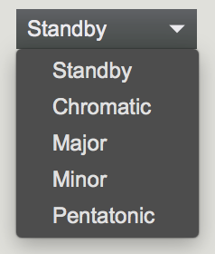

I converted the slider values within a range to the midi notes only belonging to a “scale” (for example Major scale as shown below) making the notes in C major scale equidistant from each other. The equidistant notes all belonging to a scale may make it easier to play along with.

Changing the scale does not change the visual placement of the notes on the slider board.

However, due to some shortcomings in the selection of the size of pulleys it’s a little difficult to keep the slider position mapped to a constant frequency. However, it’s easy to calibrate by moving the slider to the first note from the left and adjusting the pulley accordingly.

1. **Mapping of glove parameters** –I created two mappings
2. Gyrometer (z-axis) – controls the envelope. This maps to up-down movement of hand while keeping your elbow fixed. Keeping your hand flat compared the ground is the lower end of the gain of the envelope.
3. Gyrometer (x-axis) – controls the panning. Tilting your hand to left or right adjusts the ratio of panning.
4. Accelerometer (any) – mapping any accelerometer readings to the envelope creates interesting envelopes mapped to the movements of your hand.
5. **Reverb –** I use Soundflower to send audio from Max to Ableton Live. My Live project has two tracks ‘Left’ and ‘Right’. I am only sending the audio to Max. The algorithm that decides the ratio of the sound to be sent to ‘left’ and the ‘right’ tracks is written in max itself

1. **User Interface –** I added some gain controls for every sound engine so that the levels of different sound engines can be mixed.